Mike Yoon

CS443

Professor Hadaegh

Assignment 2

1. Write a select statement to list all the columns from the Offices table. 'Select *' is not allowed. Return the list in Office order.

SELECT office, city, region, mgr, target, sales

FROM offices

ORDER BY office ASC;

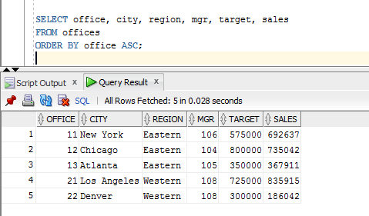

1. List the Product Name (its description), and dollar value of quantity on hand (price * quantity) . Return the list in descending order by value.

SELECT description, (price * qty_on_hand) AS dollar_amount

FROM products

ORDER BY dollar_amount DESC;

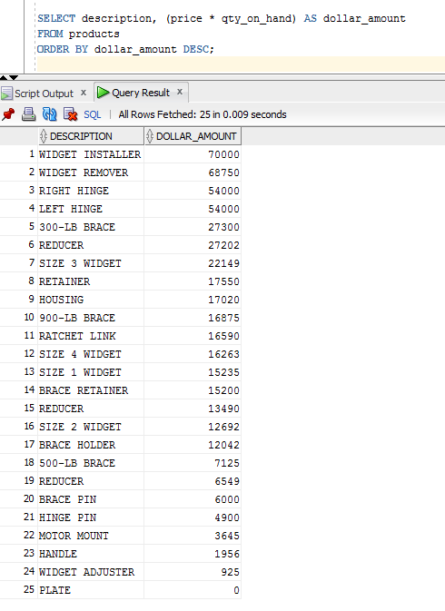

1. List the Order Number, Order Date, Customer Number and Sales Rep Number for orders for part 'XK47' or '773C'. (Use a compound search condition - OR.)

SELECT order_num, order_date, cust, rep

FROM orders

WHERE product='XK47' OR product ='773C';

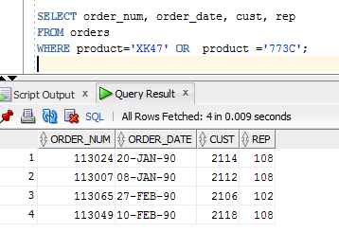

1. List the Name and Age for all Sales Reps in the following offices: 12; 21; 13. (Use the set membership test - IN.)

SELECT name, age

FROM salesreps

WHERE rep_office IN (12,21,13);

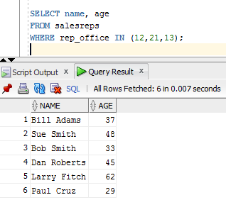

1. List the names of all Sales Reps who have the letter 'o' (this is lower case o) as the secondcharacter of their name.

SELECT name

FROM salesreps

WHERE name LIKE '_o%';

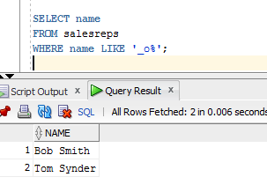

1. Return the Sales Rep ID and Name of any Sales Rep not assigned to an office yet

SELECT empl_num, name

FROM salesreps

WHERE rep_office IS NULL;

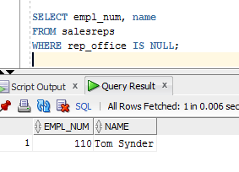

1. Show all the sales rep names with last name “Smith”.

SELECT name

FROM salesreps

WHERE name LIKE '%Smith';

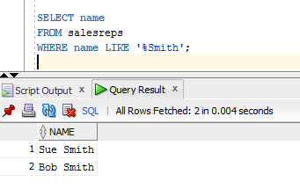

1. List different titles in the sales reps table. Only list each title once and unknown titles should be ignored.

SELECT DISTINCT title

FROM salesreps

WHERE title IS NOT NULL;

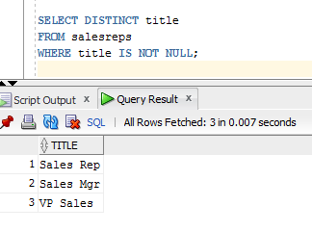

1. List the description of the products which are at least 6 character and less than or equal to 10 character long. No duplicate row is allowed. You can use the build in function length() to do this. For example, length(name) return the number of characters for attribute called “name”.

SELECT DISTINCT description

FROM products

WHERE length(description) >= 6 AND length(description) < 10;

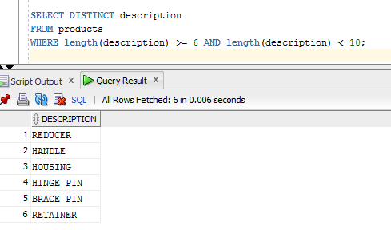

1. List the order nums with the name of the rep who placed the order and the name of the customer who made the order and the name of the rep for that customer

SELECT order_num, salesreps.name, company, cr.name

FROM orders, salesreps, customers, salesreps cr

WHERE rep = salesreps.empl_num AND cust_num = cust AND cust_rep = cr.empl_num;

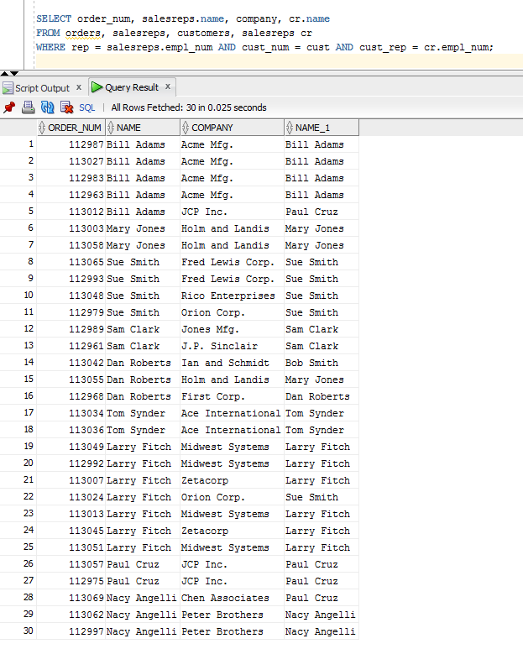

1. List the Mfr Id, the Product Id, Company and PRICE of all products brought by customers where customer number is one of (2111,2112,2105,2119) and where the amount of the order < $5500.00. Order the results by ascending Company.

SELECT mfr_id, product_id, company, price

FROM products, customers, orders

WHERE product = product_id AND mfr = mfr_ID AND cust = cust_num AND cust_num IN (2111,2112,2105,2119) AND amount < 5500.00

ORDER BY company ASC;

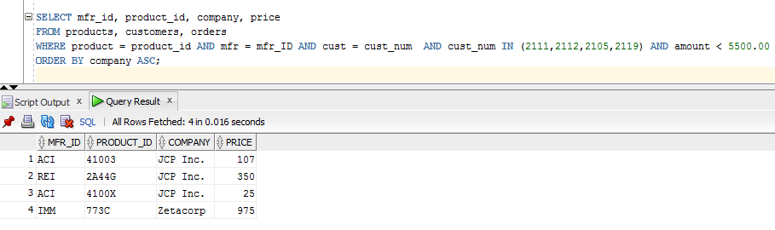

1. List all salesreps (id and names) and all orders (orderNumber) in which the salesrep is the company’s (i.e. the customer) rep (Cust Rep), but didn’t take the order. Order the result based on name in ascending order.

SELECT empl_num, name, order_num

FROM salesreps, orders, customers

WHERE empl_num = cust_rep AND rep != empl_num AND cust = cust_num

ORDER BY name ASC;

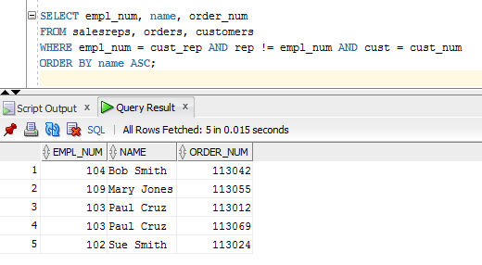

1. List all customers (Customer number, Company, and Credit Limit) and orders (Order Number, Amount) where the order is within $1000.00 of the Credit Limit (less than or equal to $10000). Sort the result by Customer number in descending order.

SELECT cust_num, company, credit_limit, order_num, amount

FROM customers, orders

WHERE cust = cust_num AND (credit_limit - amount) <= 10000

ORDER BY cust_num DESC;

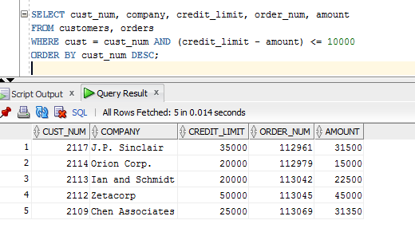

1. List all salesreps names and their managers’ names where the salesrep is at least as old as the manager.

SELECT e.name AS "EMPL_NAME", m.name AS "MANAG_NAME"

FROM salesreps e, salesreps m

WHERE m.empl_num = e.manager AND e.age >= m.age;

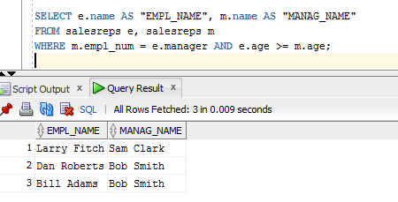

1. List all salesreps (Name) and the City they work in where the sales of the salesrep < Quota and the sales for the office is < Target.

SELECT name, city

FROM salesreps, offices

WHERE salesreps.rep_office = offices.office AND salesreps.sales < salesreps.quota AND offices.sales < offices.target;

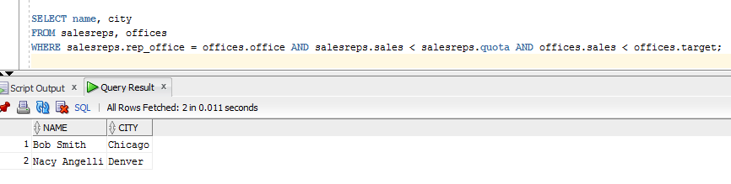

1. List the name, id, and hire date of the salesreps where at least one of the two conditions hold:

The salesrep sales should be greater than the quota

The salesrep has taken an order from Customer number 2117, 2111, or 2101.

Sort the result by the salesrep’s id.

SELECT DISTINCT empl_num, name, hire_date

FROM salesreps, orders

WHERE rep = empl_num AND cust IN (2117,2111,2101) OR (sales > quota)

ORDER BY empl_num;

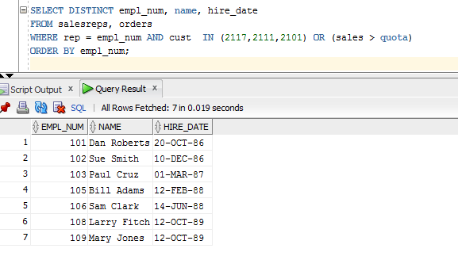

1. List all orders (Order Number) over $25500 showing the company placing the order, the Customer Rep assign to the company, the Office id and the city where the Customer Rep works in, such that the Customer Rep’s manager is not the person who actually took the order.

SELECT order_num, company, cust_rep, office, city

FROM orders, customers, offices, salesreps

WHERE amount > 25500 AND cust = cust_num AND cust_rep = empl_num AND rep_office = office AND manager != rep;

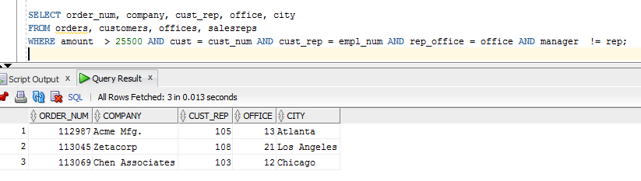

1. List order_num and name of the rep who took the order and the name of his/her manager and long as the manager’s office is in ‘New York’

SELECT DISTINCT rep AS REP_NUM, e.name AS "EMPL_NAME", m.name AS "MANAG_NAME", order_num AS “ORDER_NUM”

FROM customers, orders, offices, salesreps e, salesreps m

WHERE e.manager = m.empl_num AND m.empl_num = offices.mgr AND orders.rep = m.empl_num AND offices.city IN ('New York');

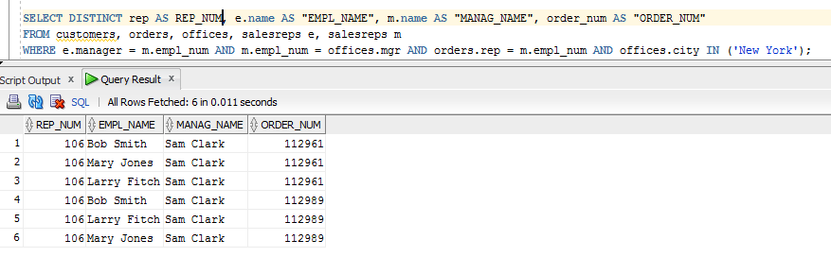

1. List all products (ProductId, and Description), customers (CustNum, Company) who have bought that product, and orders (Order Number, and Order Date) where the order < $1500. Sort the rows by the OrderDate.

SELECT product_ID, description, cust_num, company, order_num, order_date

FROM products, customers, orders

WHERE cust = cust_num AND product = product_ID AND mfr = mfr_ID AND amount < 1500

ORDER BY order_date;

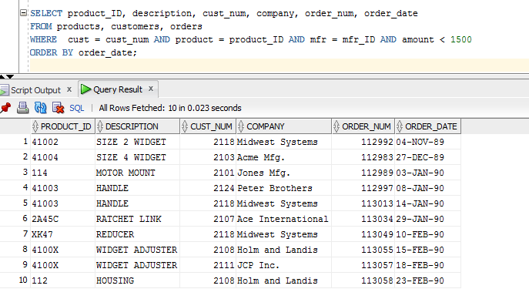

1. List the name of the salesreps and the name of their managers only if the manager has taken care of some orders.

SELECT DISTINCT e.name, m.name

FROM salesreps e, salesreps m, orders

WHERE e.manager = m.empl_num AND rep = m.empl_num;

